Drawing Hands  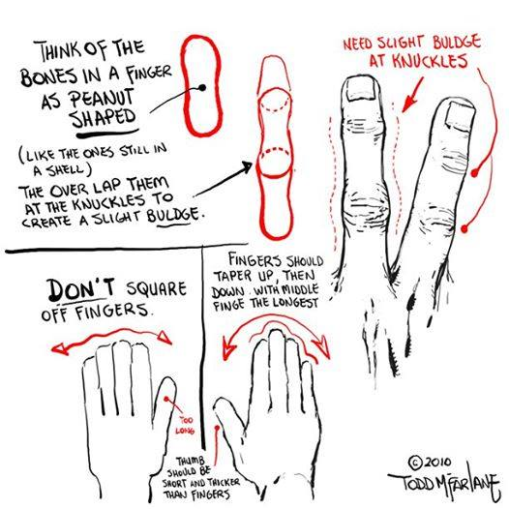  Use the space below! |  |  | Behind the Idea of Spawn  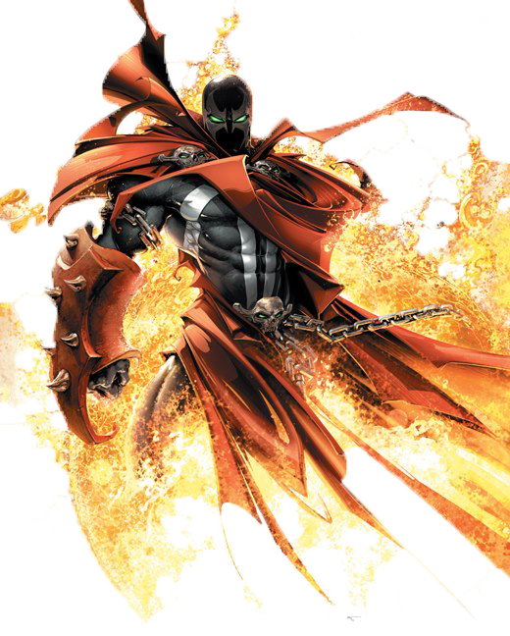

Creator: Todd McFarlane  Todd McFarlane born March 16, 196 is a Canadian cartoonist, artist, writer, toy designer and entrepreneur, best known for his work in comic books, such as the fantasy series Spawn.  In the late 1980s and early 1990s, McFarlane became a comic book superstar due to his work on Marvel Comics' Spider-Man franchise, on which he was the artist to draw the first full appearances of the supervillain Venom. In 1992, he helped form Image Comics, pulling the occult anti-hero character Spawn from his high school portfolio and updating him for the 1990s. Spawn was a popular hero in the 1990s and encouraged a trend in creator-owned comic book properties.  Since leaving inking duties on Spawn with issue No. 70 (February 1998), McFarlane has illustrated comic books less often, focusing on entrepreneurial efforts, such as McFarlane Toys and Todd McFarlane Entertainment, a film and animation studio. In September 2006, it was announced that McFarlane would be the Art Director of the newly formed 38 Studios, formerly Green Monster Games, founded by major league baseball pitcher Curt Schilling. McFarlane used to be a co-owner of the National Hockey League's Edmonton Oilers but sold his shares to Daryl Katz. He is also a high-profile collector of history-making baseballs. |  |  | Naming a Character  The Violator  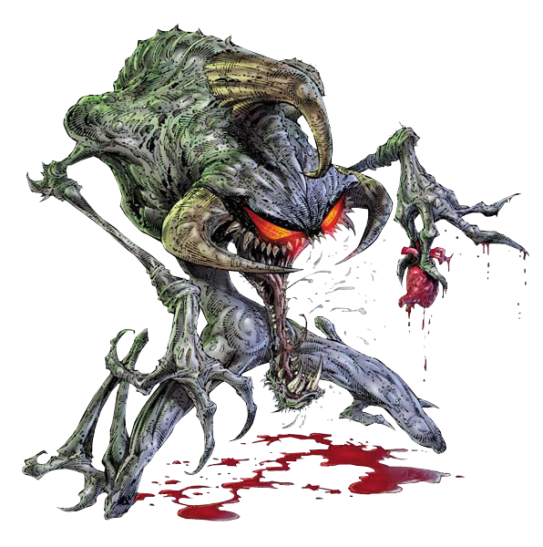 This is Spawn’s first villain and this is an idea of how one can be inspired on the spot. “The origin of his name is that on a cold, rainy night up in Canada, where I was living, my wife and I were coming home from a night out. She asked me if it was okay if we stopped at the liquor store because she wanted to pick up a bottle of wine. I said sure, but since I don't drink, I decided to wait in the car while my wife went and selected a bottle of wine. While I was relaxing there in my car, I looked out the window and noticed a sign posted on a wall. It read something like... 'No parking anytime. All violators will be towed.' I sat looking at it for a few moments and then said to myself...VIOLATOR!?!? That would make for a cool, nasty villain name!!!!!” Todd McFarlane Now, just practice drawing!
2 |  |  | 7

Spawn  Spawn was one of Todd McFarlane’s heroes from his portfolio during his high school days. He pulled it out, updated the whole model and began to map designs and ideas for this character. Spawn is about a man who makes a deal with the devil but like every deal with the devil, he does not get what he expected. Now Spawn is stuck in this war between Heaven and Hell.  Todd McFarlane claims he is an atheist.  Customizing an Idea  Even though Todd McFarlane claims to be an atheist, he is greatly influenced by Christian and Catholic religion. This is the kind of inspiration that should influence you to take a second look at everything around you and take it in to see how it can inspire you to do things you have never thought of.  Make It Picture Perfect  With a great hero, you need a great world and back story. Something that one can relate to. Todd McFarlane named a lot of his characters from friends and family. Spawn’s love life is named after Wanda, his wife. Wanda’s daughter is named after Todd’s daughter, Cyan and in the animated series, she is voiced by his younger daughter, Kate. |  |  | Media Worked In  Comic Books  Spawn became the most successful independent comic book of all time, selling 1.7 million copies during its release of Spawn No. 1. Image Comics went on to have the most successful independent comic book company.  Toy Industry  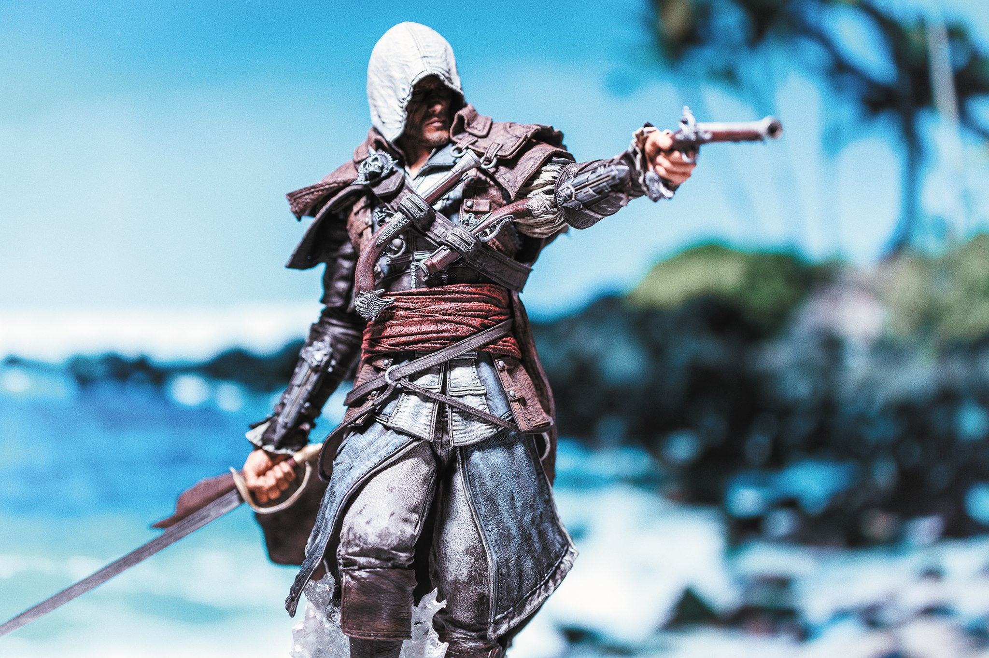 After establishing a power house of a comic book company (Image), Todd McFarlane began to do toys for many different companies, artists, and for his own characters as well.  TV and Film  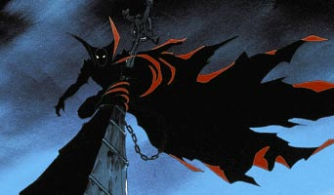 While becoming an established toy maker, Todd McFarlane also hit Hollywood and began directing. His Animated series on HBO based on his Spawn comics won Animation of the year of its debut, 1997.
6 |  |  | 3

Getting Started  Paving the Road  Todd McFarlane was not a success over night. Initially, Todd wanted to play baseball but for a few reasons, he was cut. Luckily, he was studying Graphic Design.  Todd McFarlane submitted over 700 applications and pin-ups before he finally got a chance to work in the comic book industry.  Try, Try, and Try Again…  Todd McFarlane poured all that he had into his art and did not give up. He got his chance during 1987. Todd worked on several established comics including:  - Infinity Inc. (DC Comics)  - Batman (DC Comics)  - The Hulk (Marvel Comics)  - Spider-Man (Marvel Comics)  - Ghost Rider (Marvel Comics)  Before splitting off and doing his own hero. |  |  | How to Draw…  Eyes.  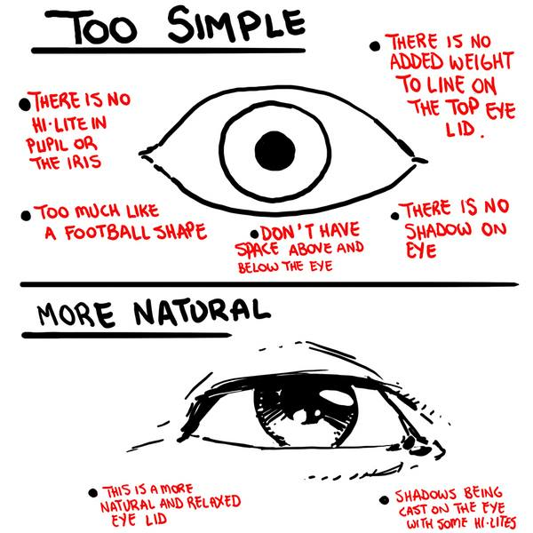 Use the space below to practice!
4 |  |  | 5

